Procedure to Manually Backup Production Data

- Login to the AWS console at http://aws.amazon.com
- Select the EC2 tab
- Select the Volumes item in the left menu
- Click on the check box for the production volume
- Click on Create Snapshot in the top right

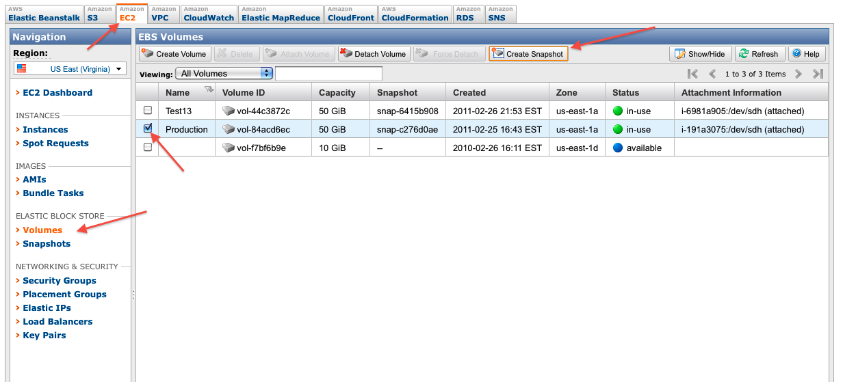
- Enter a description in the pop-up. Use the convention “Production mm-dd-yyyy”

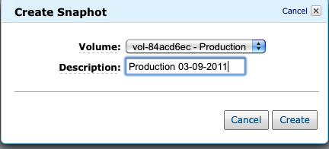
- The snapshot will proceed.
- You can view the snapshots by selecting Snapshots from the left side menu.
- Repeat the above procedure for the Test13 volume at least once a week.
- From the snapshots screen you can delete any old snap shots you don't need.
- Develop a snapshot retention plan based on site volume. For Test13 you can backup once a week and keep one per month.
- For production, consider daily snapshots where you keep all snapshots for at least a week. Every Sunday delete the Monday-Saturday snapshots from two weeks prior. This way you will have 7 backups on hand for the last week.

Week1 | End of Week 2
Monday | Delete
Tuesday | Delete
Wednesday | Delete
Thursday | Delete
Friday | Delete
Saturday | Delete
Sunday | Keep
Week 2
Monday | Keep
Tuesday | Keep
Wednesday | Keep
Thursday | Keep
Friday | Keep
Saturday | Keep
Sunday | Keep

